Stormwater Management for Renovations, Coach Houses,
1 Unit and 2 Unit Residential Developments

All new development in the City of North Vancouver must provide on property (on-site) stormwater source controls to meet requirements from Metro Vancouver and the Ministry of Environment. This document provides a background on stormwater management and outlines an approach for stormwater management for 1 and 2 Unit developments. The stormwater source controls are “green infrastructure” designed to reduce the effect of development on natural water systems, including our streams and oceans. The goal of source controls is to capture and use rainwater on each property to reduce total runoff and provide for water quality improvement.

Our goal for single family homes is to:

- capture 50% of the 24-hour Mean Annual Rainfall, or 40 mm over 24 hours from all roof,deck, and concrete areas (impervious house surfaces) from the entire site.

- direct (slope) all paving and concrete areas to garden or grassed area, and/or collect in a sump style drain basin (catch basin).

Stormwater source controls can include: rain gardens, infiltration facilities (e.g. rock pits, dry wells, underground chambers), absorbent landscaped areas, etc. These source controls used throughout North American and are well described on a variety of websites. Metro Vancouver developed a series of guidelines available at the following web location:

Metro Vancouver’s Stormwater Source Control Design Guidelines, 2012
http://www.metrovancouver.org/services/wastewater/sources/Pages/StormwaterManagement.aspx

For 1 Unit and 2 Unit developments, a professionally (e.g. Professional Engineer, Landscape Architect, etc.) prepared stormwater management plan is not required. This document is applicable for single family or duplex developments and provides a simplified approach for a system.

Background on Stormwater Management

Land development and creation of hard impervious surfaces, together with development of storm drainage sewers that discharge to our creeks, have resulted in numerous safety (e.g. erosion and slope stability) and environmental issues (e.g. water quality, pollution, loss of fish habitat, etc.).

The following are common approaches for stormwater source controls applicable for North Vancouver:

- Absorbent Landscapes: provision of good on-site soils, compost amended (absorbent) soils, or even planter boxes to contain and slowly release rainwater to the surrounding ground. Absorbent soil is a blend of organic soil, sand and compost that will infiltrate more water than compact silty soils and slow runoff response more than gravelly soils.

For lawn areas typical “Turf Blend” soils with an organic content of 8% are ideal for good infiltration and water retention. If the soil is obtained locally (e.g. North Vancouver Transfer Station – Harvest Power soil outlet), some organic soil amender should be added to increase the organic content from about 5% to 8%.

For garden areas, “Garden Blend” soil should have an organic content of 15%, and some organic soil amender could be added to the local Harvest Power product to ensure the 15% organic content.

Thick layers of absorbent soil manage the rainfall that falls on them, but could also take stormwater from patio and roof areas. This could include:

- diverting roof water or patio runoff to garden planting beds through a combination of solid and perforated pipe.
- dispersing runoff from impervious surfaces in larger grass areas with solid and perforated pipes.

Simple absorbent soil approaches (e.g. not including pumps) could cost as low as $2,500 for about 10 to 15 m² of area and would offset other landscaping costs.

- Soil Infiltration Facility: this approach incorporates the idea of underground storage and soil infiltration at one location. These facilities could include rock pits (dry wells) or could be more compact plastic chamber based systems. These systems are used widely in the City:

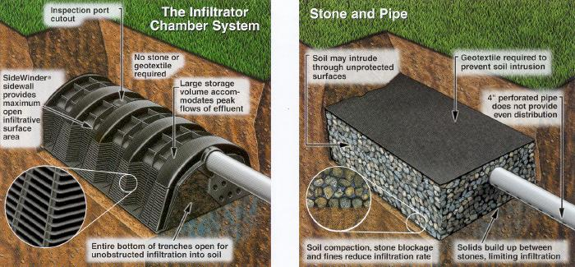
Typical Infiltration Chamber Typical Rock Pit Facility

- the rock pit approach is a low-tech version of the dry well, where roof areas are piped to a rock pit where stormwater is stored in the void areas around the rock and infiltrated into the soil below. An overflow pipe would then take excess water to the municipal storm sewer.

- for a smaller footprint area, a plastic modular box systems (e.g. Brentwood Industries Stormtank system available locally from the Emco Corp.) can be used to create a much larger open volume to store water.

These systems depend on the infiltrative capacity of the subsoil and require a balance between impervious area, facility area, and volume. Any infiltration facility must be located 5m away from any building foundation under the building code.

Simple infiltration approaches (e.g. not including pumps) could cost as low as $2,500 to $3,500 for a single family development.

- Rain Garden: this approach is a combination of absorbent landscaping and soil infiltration. These systems provide a garden area in a gentle depression to collect water from impervious areas. The top garden layer of absorbent soil filters and traps water while supporting a variety of moisture tolerant plants. All the excess water infiltrates through the organic soil layer to an underlying rock pit to store and further infiltrate water. This is a nice blend of the two approached to provide a visually appealing and active garden area, and providing extra ability to store water.

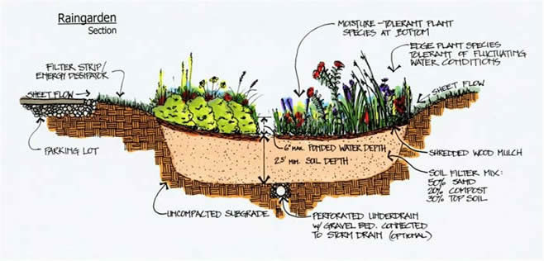
Typical Rain Garden Schematic

Typical sizing charts and layouts will be available from www.cnv.org for each of these three types of management facilities.

Simple rain garden approaches (e.g. not including pumps) could cost as low as $2,500 and would offset other landscaping costs.

- Rainwater Harvesting: large scale rainwater harvesting (larger than normal rain barrels) can be used to manage stormwater too. Harvesting and storing rainwater for non-potable uses (e.g. landscape irrigation, and toilet flushing) are complex systems that are not well supported by current building codes and would require more detailed plans, and input from a professional. These systems are considered “small water systems” and are subject to both health (Vancouver Coastal Health) and Plumbing Code requirements.

- Green roof and intensive vegetation: decreasing the impact of roof areas directly by incorporating low vegetative mats (extensive green roofs) or with intensive roof or porch level planter based vegetation is usually only done on larger multi-unit developments. This approach involves more sophisticated design of integrated roof systems and providing enough structural capacity for the vegetative system. We recommend seeking professional design expertise for this type of approach, and there maybe limitations to approaches under the building code.

A combination of these approaches can be used for most City building sites; however, some may not be possible due to other site constraints (e.g. infiltration is not usually possible for lots along ravine areas, or areas with shallow bedrock.

Prior to issuance of the building permit, the applicant must submit a stormwater
management plan, that shall include:

- a plan (i.e. site plan or schematic), outlining collection, conveyance, and on-site storage and use of all impervious or semi-impervious surfaces;

- a brief description (report) of the approach (see attached outline).

Source Control Design Steps

The following provides an approach for developing an on-site source control plan.

1. Determine total impervious area for your proposed lot:

Table 1: Example Breakdown of Lot Coverage
Area | Size (m²)
House Footprint (roof and deck areas) | 200
Garage or Coach House | 55
Pathways and Patios | 20
Grassed Areas | 200
Garden Areas | 155
Total Lot Size | 630

2. Select approaches for source control:

Pervious areas (like grass and gardens) should not require additional source controls, especially if a sufficiently deep layer of soil has been used on the property. These areas have the capacity to control stormwater from roofs and other areas. Based on the areas outlined above and a site plan, identify areas for possible source controls.

From the types of systems above and based on the available technical information, select a preferred source control method.

3. Conduct an infiltration test for any proposed soil infiltration approaches (e.g. rain gardens or stormwater - soil infiltration facilities).

A typical procedure is outlined in the following steps, and is based on the BC Sewerage System Standard Practice Manual (2007) – Appendix E. This document is available on-line for more information. Alternatively, a geotechnical engineering or materials testing company could be hired to complete the test.

- dig a test pit (by shovel or by machine) to the depth of possible infiltration or about 1.2 to 1.5 m.

- the bottom of the test pit should be hand shoveled to about 0.3 m by 0.3 m by 0.3 m (12” by 12” by 12”) and cleaned of any loose soil.

- once dug, the hole should be soaked and filled at least 30 cm (12”) deep (if the bottom of the hole is clayey soil, the hole should be soaked for about 4 hours). When the hole has 12.5 cm (5”) or less, the procedure should be repeated and filled to 30 cm and allowed to drain to 12.5 cm.

- to conduct the test, top up the hole to a depth of 15 cm (6”) and allow to drain to 12.5 cm (5”) and measure the time for infiltration of 2.5 cm (1”). Repeat this test at least two more times or until the last two measurements are within 2 minutes of each other.

- the design rate is the average of the last two measurements. A useful infiltration rate is mm/hour (e.g. measurement of 20 minutes per 2.5 cm (e.g. 2.5 cm / 20 min x 600) is 75 mm/hour

Take a photograph of the test hole and soil excavated for reference.

4. A simple summary table should then be developed outlining the contributing areas and infiltrative capacity.

Table 2: Example Breakdown of Impervious Areas
Area | Area (m²) | Area (ft²)
House Footprint (roof and deck areas) | 200 | 2150
Garage | 55 | 600
Pathways and Patios | 20 | 215
Total Impervious Area | 275 | 2,965

- The following table is outlines the size (area) and depth of a rock pit style infiltration stormwater source control, based on a total roof area of 200 m².

Table 3: Example Rock Pit Size for 200 m² Roof Area
Soil Permeability of 2mm/hr |  | Soil Permeability of 10mm/hr |  | Soil Permeability of 50mm/hr
Facility Area: (m²) | Minimum Facility Depth (m) | Facility Area: (m²) | Minimum Facility Depth (m) | Facility Area: (m²) | Minimum Facility Depth (m)
17.75 | 1.2 | 12.5 | 1.2 | 5.5 | 1.2
32 | 0.6 | 18.25 | 0.6 | 7.25 | 0.6
53.5 | 0.3 | 24.75 | 0.3 | 9.75 | 0.3

- Stormwater Source Control Plan Submission

The stormwater source control plan submission should include a short description of the approach:

- document the infiltration test
- list the source controls that are proposed
- provide the key tables outlining the total water allocation

One source control drawing should be provided. This can be added to a building site plan using a graphics program, word processing program, or by hand. Key elevations should be noted on the plan for:

- 5m setbacks from foundation to any infiltration facility (e.g. rock pit or chamber).
- elevation of footing drains (from building plans)
- bottom elevation of any source controls
- proposed final grade of yard areas
- elevation of the storm sewer
- all facilities should disperse water through perforated pipes (12mm diameter at 150mm) and shall be piped continuously through the facilities to allow overflow
- all facilities should have an observation well (inspection chamber) to allow inspection and maintenance (see typical drawing)

In the event of questions, City engineering staff can provide a quick “counter” review to assist in plans not developed by professionals or designers.

The following two pages provide a typical example based on the Tables 2 and 3

Other Tools and Resources:

References:
GVRD’s Stormwater Source Control Design Guidelines, 2012
http://www.metrovancouver.org/services/wastewater/sources/Pages/StormwaterManagement.aspx

Province of British Columbia Stormwater Planning: A Guidebook for British Columbia.
http://www.env.gov.bc.ca/epd/mun-waste/waste-liquid/stormwater/index.htm

Images sourced from:

https://www.thenaturalhome.com/infiltrator.htm

http://srrcd.ca/programs/rain-gardens/

Example Stormwater Management Plan for 1 Unit and 2 Unit Facilities

Address: 141 West 14th Street

Proposed Development: 1 Unit House with detached garage

Summary of Impervious Areas:
Area | Area (m²)
House Footprint (roof and deck areas) | 200
Garage | 55
Pathways and Patios | 20
Total Impervious Area | 275

Infiltration Results at Location and Depth
Infiltration Measurement (minutes/inch) | Depth of measurement | Rate mm/hr
110 | 1.2 m | 13.9
115 | 1.2 m | 13.3
118 | 1.2 m | 12.9
Average: 114.3 |  | 13.3
Conversion: 1/[min/inch] x 1524 = [mm/hr]

Include photos of soil from the test pit and infiltration test.

Stormwater Management Approach (Source Control): Rock pit infiltration

Proposed Facility Dimensions:
Facility and Catchment Area (m²) | Depth (m)⁽¹⁾ | Required Area (m²)⁽¹⁾ | Width (m) | Length (m) | Proposed Area (m²)
East Rock Pit (100) | 1.2 | 6.25 | 1.5 | 4.2 | 6.3
West Rock Pit (100) | 1.2 | 6.25 | 2 | 3.2 | 6.4
Garage Rock Pit (55) | 0.6 | 5.1 | 1 | 5.1 | 5.1
--
(1) Available sizing charts from City Hall

