# City of North Vancouver decorative background cover.City of North Vancouver Accessibility Plan

2025 – 2028

July 2025

Learn more at: [cnv.org/Accessibility](https://www.cnv.org/community-environment/social-planning/accessibility).

## Your Accessibility Feedback

We invite you to share your thoughts and experiences with us. If you encounter any accessibility challenges while interacting with the City of North Vancouver or our services, please use one of the channels listed below to let us know.

Feedback will be reviewed by the City’s Accessibility Working Group, who will identify possible actions to remove or mitigate the impact of barriers.

Ways to provide feedback:

* Via the [CityFix](https://www.cnv.org/City-Hall/Online-Services/CityFix) App
* Via the [Service Request Form](https://www.cnv.org/City-Hall/Online-Services/Service-Request)
* Email your feedback to [Accessibility@cnv.org](mailto:Accessibility@cnv.org)

**Social Media:**

You can share your feedback with us on our social media channels.

* [Facebook](https://www.facebook.com/CityOfNorthVancouver)
* [Instagram](https://www.instagram.com/CityOfNorthVancouver/)
* [YouTube](https://www.youtube.com/user/CityOfNorthVancouver)
* [LinkedIn](https://www.linkedin.com/company/city-of-north-vancouver/posts/?feedView=all)

## Table of Contents

Your Accessibility Feedback 2

Acknowledgments and Key Information 5

Territory Acknowledgment 5

Thank You 6

Accessibility Statement 7

A Note About Language 7

Important Terms and Concepts 10

Disability 10

Impairment 11

Barrier 12

Accommodation 13

Accessibility 13

Accessibility and Accommodation 14

Ableism 16

A Message From the Mayor 17

Introduction 20

Who We Are 21

Accessibility and Our Strategic Vision 22

Accessibility and Our Vision for Community Wellbeing 23

Accessibility and Our Vision for Community Mobility 29

The Vision: Healthy Streets That Work for Everyone 30

The Goals 31

Our Accessibility Commitment 33

Other Commitments 33

Our Partners in This Work 35

Community Partners 35

North Shore Accessibility Advisory Committee 38

Committee Purpose 38

Composition 39

Accessibility Work to Date 42

Accessibility as Design Element in the New Harry Jerome Community Recreation Centre 42

Curb Access and Parking Plan 44

City Policy on Accessibility 45

Digital Accessibility 45

Built Environment Accessibility 46

Staff Accessibility Groups 47

Successes of the Accessibility Advisory Committee 51

Legislation Guiding This Plan 52

The Accessible BC Act 52

The Accessible Canada Act 59

Barrier Identification and Removal 60

How Barriers Show Up in City Life 63

Accessibility Action Plan 77

Employment 77

Service Delivery 82

The Built Environment 88

Information and Communications 95

Transportation 102

Procurement 119

Monitoring and Evaluation 121

## Acknowledgments and Key Information

### Territory Acknowledgment

We respectfully acknowledge that we live and work on the traditional and unceded territories of Skwx_wú7mesh (Squamish) and slilwlta (Tsleil-Waututh) Nations. The City of North Vancouver is committed to Reconciliation with these Nations, who have lived on these lands since time immemorial.

### Thank You

The City of North Vancouver (CNV) expresses sincere gratitude to the North Shore Accessibility Advisory Committee for their invaluable contributions to this Accessibility Plan. Their insights, dedication, and advocacy have inspired and shaped much of the barrier identification and action planning work. The work of this group has helped the City move towards a more inclusive and accessible future.

The City would also like to thank all other people with lived experience and accessibility expertise who have supported this work. This Accessibility Plan is the culmination of the collective efforts of those who generously shared their knowledge, experiences, and perspectives to help the City identify and understand barriers to access and strategize solutions.

A final thanks to [Untapped Accessibility](https://untappedaccessibility.ca) for their support in drafting this plan.

### Accessibility Statement

This guide is accessible to PDF/UA standards. If you need a copy of our accessibility plan in a different format such as braille, please email us at [accessibility@cnv.org](mailto:accessibility%40cnv.org?subject=).

### A Note About Language

The City of North Vancouver acknowledges that the language surrounding disability is constantly evolving – and that preferences for terminology vary. As a small gesture to recognize preferences, this Accessibility Plan alternates between “person-first” and “identity-first” language.

“Person-first” means acknowledging the individual before referencing their disability. For example, saying “person with a disability”. This language reflects the belief that disability is separate from the person. It treats disability as a single aspect of who the person is, rather than their defining feature. “Identity-first” means acknowledging the identity before the person. For example, saying “disabled person”. This language reflects the belief that disability is part of one’s identity and is inherent and inseparable from who they are.

The City also recognizes that using an individual’s preferred terminology is best practice when communicating with them directly.

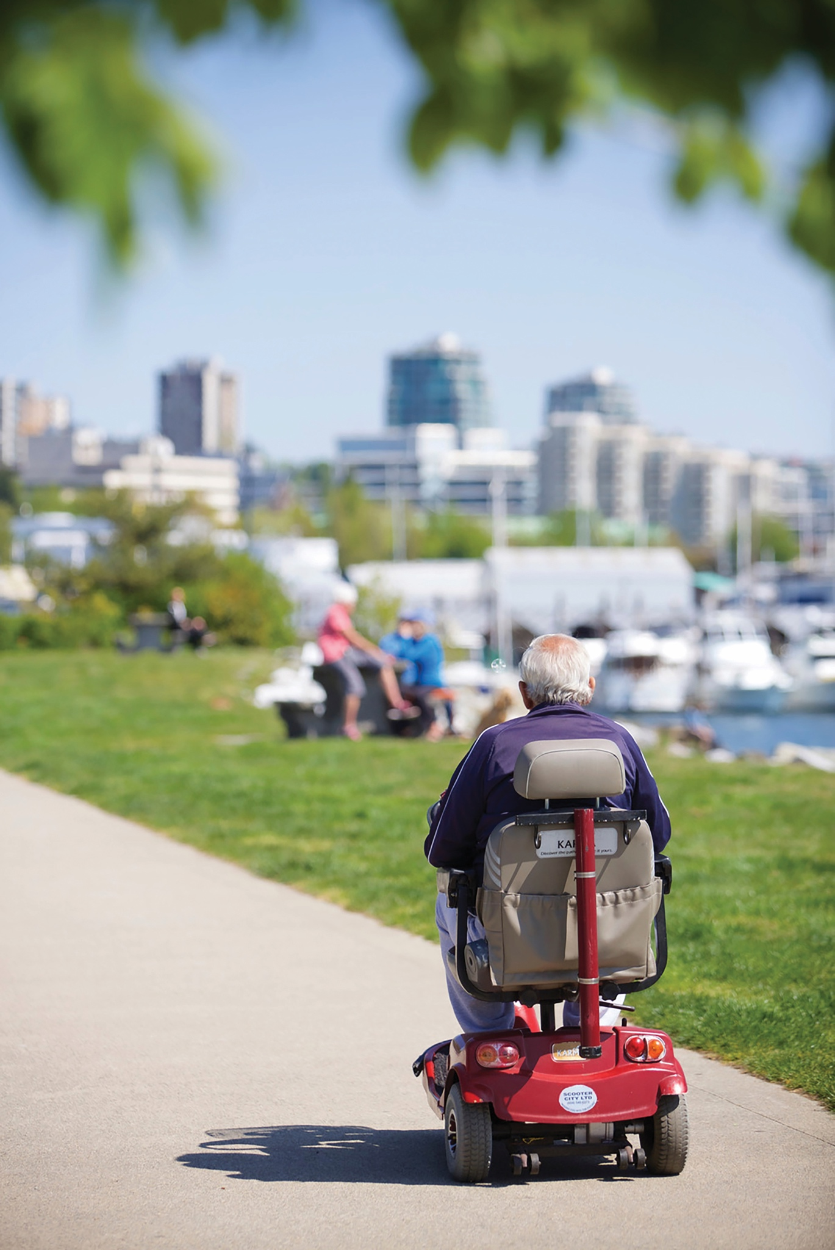

## Important Terms and Concepts

Our understanding of disability and accessibility is evolving. The following definitions will help ground this plan in the current definition of key terms.

### Disability

According to the [Accessible BC Act](https://www.bclaws.gov.bc.ca/civix/document/id/complete/statreg/21019)*,* disability is the result of an impairment interacting with a barrier. When this interaction minimizes someone’s ability to fully and equally participate in society, disability occurs.

This definition focuses our work on removing and preventing the barriers that people may encounter. By this understanding, organizations like local governments play a critical role in how their residents, staff, and community members experience disability. We can proactively identify and remove barriers to make our spaces more accessible.

### Impairment

The [Accessible BC Act](https://www.bclaws.gov.bc.ca/civix/document/id/complete/statreg/21019)describes impairment as physical, sensory, mental, intellectual, or cognitive conditions. The *Act* also recognizes that impairments can be permanent, temporary, or episodic.

Although the *Act* uses the term impairment to describe a key component of the disability experience, it is not widely used in the disability community. It can have negative connotations that imply there’s a better way of being. For this reason, we will not be using the term impairment in this Accessibility Plan.

### Barrier

A barrier is anything that hinders someone’s full and equal participation. The *Act* states that barriers can be caused by many factors including:

* Physical environment
* Attitudes
* Policies and practices
* Information
* Communications
* Technology

Barriers can also be affected by intersecting forms of discrimination.

### Accommodation

Accommodation is a specific adjustment or modification made to address a single barrier. Accommodations are made in response to one disabled person’s experience. And they are often initiated at the request of that person. The goal of accommodations is to ensure the individual can fully and equally participate, contribute, or engage.

Accessibility and accommodation are not the same thing.

### Accessibility

Accessibility is the intentional and proactive work we do to identify, prevent, and remove barriers for people with disabilities. According to the [World Health Organization’s World Report on Disability (2011)](https://www.who.int/teams/noncommunicable-diseases/sensory-functions-disability-and-rehabilitation/world-report-on-disability), accessibility ensures that environments, services, and products can be accessed by as many people as possible – in particular, people with disabilities.

With an accessibility focus, organizations like local governments take on the responsibility of creating environments, services, and products that work for as many people as possible. This takes the pressure off people with disabilities to constantly have to initiate the accommodation process to ensure their own access.

### Accessibility and Accommodation

Although accessibility is the ultimate end goal, there’s still a time and place for accommodation. Regardless of how accessible your organization is, people will have specific access needs that still need to be accommodated. The goal is to be as accessible as possible and openly invite and provide additional accommodation as needed.

When you design for accessibility from the outset, you will save time and money on accommodations down the line. You can also use accommodations to improve the accessibility of your organization by making the adjustment or modification available to everyone. This is a great way to continue building the accessibility of your organization.

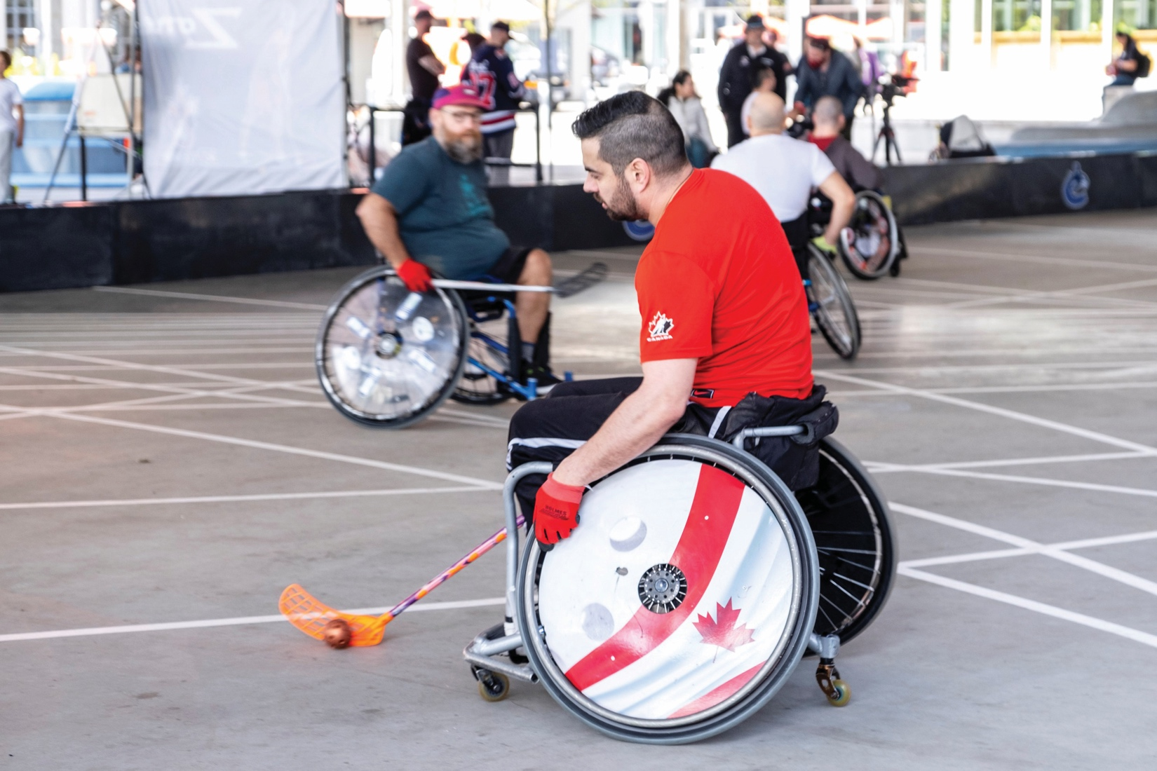

### Ableism

Ableism refers to attitudes, behaviors, and systems that disadvantage or discriminate against people with disabilities. It’s based on the idea that people without disabilities are more capable or valuable. It can be both intentional and unintentional, and it exists across policies, environments, and daily interactions. Recognizing and addressing ableism is essential for building truly inclusive and equitable communities.

At the system level, ableism disadvantages or excludes disabled people. For example, systemic ableism results in low availability of mental health services and building codes that permit wheelchair access at the back of a building instead of the main entrance.

At the institutional level, ableism can show up in how organizations design programs or policies. For example, a printed recreation program guide that is not available in large print, or a complaint line that only accepts voice calls.

## A Message From the Mayor

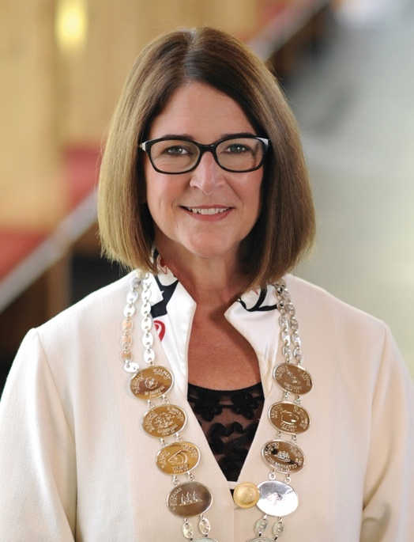

**Mayor Linda Buchanan, City of North Vancouver**

On behalf of Council, I am proud to introduce the City of North Vancouver’s first Accessibility Plan—a meaningful milestone in our commitment to building a more inclusive community. This plan represents a deep commitment to ensuring that all residents—regardless of ability—can access and participate fully in the City’s services, public spaces, and communications. It reflects our shared vision of a city where equity, clarity, and barrier-free design are not just ideals, but everyday realities.

At the heart of this work is our goal to become the ‘Healthiest Small City in the World.’ Advancing accessibility, fostering inclusion, and cultivating a welcoming community are essential to achieving that vision. This plan lays out a clear path forward to remove barriers and create opportunities, particularly for people with disabilities who continue to face systemic challenges.

We are incredibly grateful to the North Shore Accessibility Advisory Committee, local disability-serving organizations, individuals with lived experience, and City staff whose insight and advocacy have shaped this plan. Their time, expertise, and dedication have been instrumental in bringing this vision to life.

While the plan sets out a vision for the future, much of the work is already underway. As a living document, it will evolve—guided by ongoing dialogue, new understanding, and the diverse experiences of our community. We recognize that accessibility is not a one-time goal, but a continuous process of learning, listening, and improving.

We are proud to move ahead together and look forward to building a more inclusive, equitable, and accessible City—for everyone.

Sincerely,

Linda C Buchanan

## Introduction

Welcome to the City of North Vancouver Accessibility Plan! This plan outlines our commitment to creating a more inclusive and accessible community.

In our local government’s history, people with disabilities have not been fully involved in planning and service delivery. This has led to the creation of many barriers throughout civic life. To realize the City’s longstanding vision of being a vibrant, diverse, and livable community, our government acknowledges that much work needs to be done to remove barriers, build accessibility, and engage community members with disabilities in future planning.

In addition to highlighting the City’s accessibility accomplishments, this plan spotlights barriers across various sectors that still impact residents, staff, and community members with disabilities. The action plan section shows how our government will address these barriers and promote equitable access and engagement.

This Accessibility Plan is a small but meaningful step towards creating an inclusive and thriving city where every individual can fully participate and engage with their community.

## Who We Are

The City of North Vancouver is a dynamic and growing community. Despite our modest size of 12 square kilometers, we offer a wealth of amenities, attractions, services, and industries.

Our longstanding vision is to be a vibrant, diverse, and livable community that balances social, economic, and environmental needs. Accessibility is an integral part of this vision, as it ensures disabled residents are part of the fabric of this diverse and vibrant community – contributing to the City’s social, economic, and environmental success. It also ensures all community members have what they need to live well in our community.

### Accessibility and Our Strategic Vision

The [Council Strategic Plan for 2022 to 2026](https://www.cnv.org/city-hall/mayor-council/council-strategic-plan) outlines a more specific vision for the near future – to be the “Healthiest Small City in the World”. One of the priority areas guiding this work is to become “a city for people”. A key action toward this goal is to improve the City’s accessibility, making information, activities, and the environment meaningful and useful to all.

Accessibility is also important to other priority areas. For example, becoming “a connected city” requires improving our wayfinding using signage, colour, and design to support all people to move through the City. Accessibility is critical to good design of signage and other wayfinding features.

As another example, becoming “a vibrant city” requires activating public spaces for all residents to gather, interact, and engage in activities. Accessibility plays a major role in creating these spaces for everyone.

### Accessibility and Our Vision for Community Wellbeing

The [Community Wellbeing Strategy](https://www.cnv.org/community-environment/social-planning/community-wellbeing) is a plan to improve how people in the City live and connect with one another. It acknowledges the increasing diversity of the City and aims to address the evolving needs of everyone.

The [Community Wellbeing Strategy](https://www.cnv.org/community-environment/social-planning/community-wellbeing) includes six focus pathways that reflect a wide range of priorities—accessibility being one of them. These priorities will be brought to life over time through various projects across the city.

While the strategy covers a broader scope, accessibility remains a central focus. This is a long-term effort, and we’ll continue learning and improving along the way. Some accessibility actions are already in progress as part of this first version of the City’s Accessibility Plan. Additional actions will be introduced in future updates as we continue working toward our long-term goals.

#### 1. Complete Communities

The focus of this area is to ensure our land use and zoning decisions help create places that are welcoming, lively, and attractive. This should make it easy for people to socialize, build connections, feel safe, and make healthy choices. By focusing on good design, we aim to make walking and rolling more comfortable and convenient, so it’s the best option to access daily needs, close to home

By designing *complete communities*, we ensure our public spaces and services are accessible and functional. This encourages social connection and convenience for all people – including people with disabilities.

#### 2. Housing for All

This area focuses on supporting efforts to address the housing crisis. To do this, we need the right mix of housing options. This means offering different types of homes at various prices for people at all life stages and people with varying abilities and incomes. Our focus is to ensure everyone can stay in their community as their needs change. It’s also important that housing is well-designed, high-quality, and sustainable.

Housing for all emphasizes equitable access to safe and sustainable housing that can meet the evolving needs of all residents – including residents with disabilities.

#### 3. A City for the Ages

People of all ages have shared and unique needs. Some of these needs can be met by creating intergenerational solutions, while others require targeted approaches for specific age groups. “A city for the ages” focuses on making sure there are places, programs, and services that support health and wellness for everyone.

*A city for all ages* recognizes that accessibility is part of intergenerational and age-specific solutions.

#### 4. Accessibility, Diversity, Equity & Inclusion

The focus of this areas is to design spaces, programs, and services that are welcoming to everyone. This means learning about and removing the barriers caused by historical and current issues like oppression, racism, ableism, colonialism, and social inequalities.

Addressing *accessibility, diversity, equity, and inclusion* involves breaking down barriers so everyone can fully participate in community life – including people with disabilities.

#### 5. Poverty Reduction & Inclusive Economy

Though higher levels of government are crucial to reducing poverty, our local government also has a role to play. Our focus under this area is to:

* Provide easy access to services
* Work with partners to promote stable jobs, fair wages, and affordable housing

*Reducing poverty and fostering an inclusive economy* enhances access to essential services, stable jobs, and affordable housing. This is especially important for people with disabilities who are more likely to live in poverty. According to [DABC’s Recommendations to Update TogetherBC: BC’s Poverty Reduction Strategy April 2023](https://disabilityalliancebc.org/dabcs-recommendations-to-update-bcs-poverty-reduction-strategy/), many people from BC’s disability population face “two times higher poverty rates, worse housing outcomes and incur higher and additional expenses for basic needs of daily living than persons without disability” (pg. 2).

#### 6. Partnerships, Advocacy & Financial Supports

Because many areas of community wellbeing involve different organizations, the focus of this areas is to:

* Build mutually beneficial partnerships
* Advocate
* Source funding opportunities that benefit everyone

These efforts are based on shared goals, trust, and respect. The aim is long-term improvements and better health outcomes for the community.

Strong *partnerships, advocacy,* and *financial support* ensure accessibility remains a priority across all areas of community wellbeing.

### Accessibility and Our Vision for Community Mobility

The Mobility Strategy is the City’s plan to create a more balanced and inclusive transportation system—one that gives people better choices for how they move and supports vibrant, welcoming public spaces. Shaped through collaboration with community members, partners, and local organizations, the strategy reflects a shared vision for how we want our streets to look, feel, and function over the next decade. At its core, this is our roadmap for building healthy streets that work for everyone—making it easier, safer, and more enjoyable to get around while enhancing the overall quality of life in our community.

### The Vision: Healthy Streets That Work for Everyone

The City of North Vancouver is working toward streets that are safe, welcoming, and support a variety of ways to get around. While driving remains an important use, our streets also play a key role in connecting people who walk, bike, take transit, or use mobility aids. This vision is about creating spaces that serve all these needs while removing barriers, so everyone can move comfortably and confidently. By making our streets more inclusive and flexible, we’re helping people of all ages and abilities stay connected, active, and involved in their community.

### The Goals

The City’s vision for healthy streets is guided by four key goals that reflect our commitment to a vibrant, inclusive, and sustainable future:

1. Our streets help our City prosper and be a vibrant place – Streets are essential to creating a lively city where people can meet, shop, and enjoy public spaces, alongside the efficient movement of goods, contributing to both economic growth and community wellbeing
2. Our streets support real and accessible choices for how we move around – A more connected transportation network ensures that everyone has reliable, convenient options for getting around, whether by walking, biking, transit, or driving
3. Our streets are safe and comfortable – Safety is a top priority. The City is committed to eliminating serious injuries and fatalities, making streets safe and welcoming for all users
4. Our streets reduce our impact on climate change and the environment – With transportation as a major source of emissions, the goal is to reduce environmental impact by promoting cleaner, low-carbon travel options, helping the City reach its target of net zero emissions by 2050

### Our Accessibility Commitment

Accessibility is deeply embedded in all visions for our City’s future. Recognizing this significance, the City of North Vancouver is committed to improving accessibility for residents, municipal staff, and other community members with disabilities. By prioritizing accessibility, we can foster a truly vibrant, diverse, and livable community where everyone thrives.

### Other Commitments

As City Council carries out this commitment to accessibility, their promise is to remain:

* **Open:** Being accessible, transparent, accountable, and communicative
* **Inclusive:** Respecting, considering, and including diverse perspectives
* **Responsible:** Balancing responsibilities, including planning, environmental conservation, fiscal responsibility, and community well-being to ensure long-term sustainability
* **Progressive:** Finding innovative approaches and   
  partnerships that advance our City
* **Engaged and informed:** Harnessing the power of data, the professional and lived expertise of staff with disabilities, and the invaluable insights of our disabled community members to make informed decisions together

## Our Partners in This Work

### Community Partners

The City has connected with several disability service organizations who provided input on barriers experienced by their client groups and made recommendations to remove or mitigate the impact of these barriers.

The purpose of connecting with these organizations is to open a two way communication channel, to hear feedback on barriers experienced by their organizations and the clients they support, and to share our progress and challenges as we work to improve accessibility at the City.

We look forward to continuing our relationship with these partners as we implement and evolve our accessibility plan.

Our thanks extend to these organizations for their feedback and the work they do to support residents with disabilities:

* [Spinal Cord Injury BC](https://sci-bc.ca)
* [HYAD – Home for Young Adults with Disabilities](http://www.hyad.ca)
* [North Shore Disability Resource Centre](https://nsdrc.org)
* [Intellectual Disabilities Society](https://idsbc.org)
* [BC Centre for Ability](https://www.bc-cfa.org)
* [Canadian National Institute for the Blind](https://www.cnib.ca/en?region=on)

#### Further Partnership

We’re pleased to report that the North Shore Disability Resource Centre and the Intellectual Disabilities Society will also be joining the North Shore Accessibility Advisory Committee formally to provide their organizational perspectives on an ongoing basis.

#### Accessible Employment Resources

We’ve also established relationships with organizations who can help us advance accessibility for our employees.

We’re partnering with [CANWiN](https://www.canadianpartnerswin.ca/), a national program supporting employers to become more inclusive, and the City has joined the [Community of Accessible Employers](https://accessibleemployers.ca), which will provide access to training and other free resources.

### North Shore Accessibility Advisory Committee

Formerly known as the North Shore Accessibility Committee on Disability Issues (NSACDI), the North Shore Accessibility Advisory Committee is a regional committee that supports the City of North Vancouver, and the Districts of North Vancouver and West Vancouver to remove barriers and improve accessibility for residents, staff, and other community members with disabilities.

### Committee Purpose

The purpose of this committee is to support the North Shore municipal partner organizations by:

1. Identifying barriers for people with disabilities who interact with our government organizations, seek services, and/or participate in community life.
2. Providing advice on how to remove and prevent barriers identified by the committee or the community via feedback processes.
3. Providing an accessibility lens on municipal plans and projects including accessibility plans.

### Composition

The committee includes a maximum of 15 voting members from the three partner municipalities. Membership requirements include:

* At least half of the members are community members with disabilities; others may be community members who support persons with disabilities.
* Three members are individuals from organizations on the North Shore that support persons with disabilities. When recruiting members from disability-serving organizations, people who also bring lived experience of disability are prioritized.
* At least three members are Indigenous persons, to the extent possible.
* There is balanced representation across the three North Shore communities.
* Committee members reflect the diversity of disabilities and persons in British Columbia. This includes the full demographic spectrum in each participating municipality.

Members generally participate on the committee for a two-year term.

#### Consulting With the North Shore Accessibility Advisory Committee on the Accessibility Plan

City staff consulted with the North Shore Accessibility Advisory Committee in fall 2024 to support the development of this plan. The Committee had previously provided input on accessibility barriers to the Districts of North Vancouver and West Vancouver in 2023.

In the first meeting, staff shared the City’s proposed approach to identifying barriers. This approach involved reviewing the Committee’s previous feedback to the other North Shore municipalities to see what applied to the City of North Vancouver, as well as identifying additional barriers specific to our community. Staff asked the Committee whether this approach was appropriate and invited their input before moving forward. A draft framework for organizing the plan, based on the standard areas in the Accessible BC Act, was also introduced.

In the second meeting, staff and Committee members reviewed the previously gathered feedback together. The Committee was asked which parts were also relevant to the City of North Vancouver to help avoid duplication and ensure meaningful engagement. Members also offered further context and shared additional barriers to help shape the plan’s direction and actions.

## Accessibility Work to Date

### Accessibility as Design Element in the New Harry Jerome Community Recreation Centre

Through 2025 and early 2026, the City will be completing a new community recreation centre, replacing the 59 year old Harry Jerome Recreation Centre. Driven by the City’s vision of A Healthy City for All and guided by the City’s Community Recreation Strategy, the new community recreation centre is focused on physical and mental wellness, inclusion, accessibility, and diversity.

The new facility is pursuing the gold standard in the Rick Hansen Foundation Accessibility Certification program.

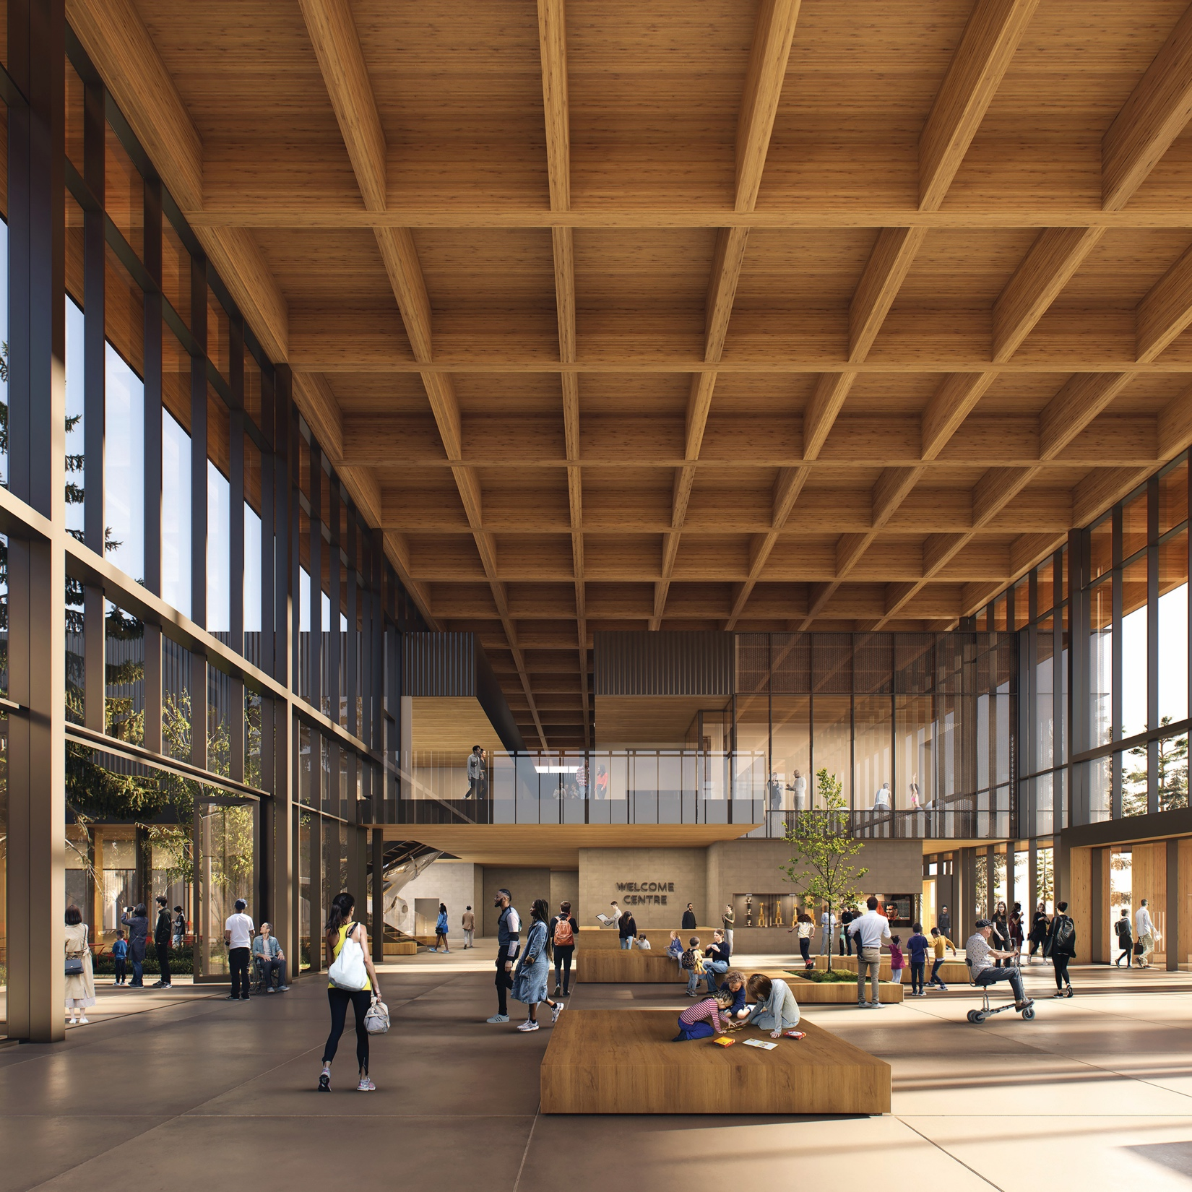

### Curb Access and Parking Plan

The City of North Vancouver Curb Access and Parking Plan was approved on April 14, 2025. It introduces more equitable parking policies, so that community members have greater opportunity to access the curb when and where needed.

Accessible design is one of the provisions in the plan, which includes providing priority or barrier-free parking spaces for vehicles displaying an accessible parking placard issued by the [Social Planning and Research Council of BC (SPARC)](https://www.sparc.bc.ca).

The City is implementing the plan in phases, focusing on areas with the highest parking use, Lower and Central Lonsdale, first. Parking changes in these areas will take effect in September 2025, with ongoing monitoring to adjust for any unforeseen impacts on curb space.

### City Policy on Accessibility

The City has incorporated accessibility as a fundamental element in policy development for a wide range of City plans and strategies. For example, accessibility is now considered in the Community Wellbeing, Mobility, Economic and Climate and Environment Strategies and major policy documents.

### Digital Accessibility

In 2024, the City began addressing digital accessibility, including conducting a formal assessment of the City’s website.

Significant improvements have been made to announcements and navigation on the main menu.

The search function has been improved for screen reader users, voice-assisted technology users, and users who navigate the site with keyboard only. ARIA labels, which help screen reader users navigate the site, have also been improved.

This accessibility plan includes actions to continue the work to identify and remove barriers on our website and in electronic documents.

### Built Environment Accessibility

During the spring of 2025, we conducted assessments of two main City owned and managed properties to identify accessibility barriers in the built environment. We audited the City of North Vancouver City Hall and the Gerry Brewer building, which is the home of the North Vancouver RCMP, North Shore Emergency Management, the North Shore Restorative Justice Society, and the City of North Vancouver Police Support Services and Bylaws. The CNV Accessibility Working Group will review the findings and evaluate possible actions to remove them or mitigate their impact.

### Staff Accessibility Groups

Although the North Shore Accessibility Advisory Committee is critical to our accessibility work, their primary role is to advise and make recommendations. We understand that we alone are responsible for creating real, lasting change in the way our local government operations. For this reason, we have established three internal groups to support and drive our City’s accessibility work.

#### Accessibility Working Group

This group is made up of City staff across each department. The role of the group is to:

1. Identify barriers related to each department
2. Propose actions
3. Lead and support implementation of these actions

#### Accessibility Steering Group

This group is made up of key leaders from each department. Collectively, this group is responsible for streamlining decision-making regarding this Accessibility Plan. As individual contributors, group members are also responsible for championing accessibility in their department.

#### Lived Experience Representation

Members of the working group and steering group were selected based on their understanding of their departments and their influence on decisions that impact accessibility. We also recognize the importance of ensuring lived experience of disability is represented in the internal groups.

In 2024, we surveyed the Accessibility Working Group and Accessibility Steering Group groups, and we found that 22% of members self-identified as having a disability and a further 11% are caregivers of someone with a disability.

#### Accessibility Employee Resource Group

In 2025, with the participation of employees from all departments across the City, we launched an accessibility-focused employee resource group. The Accessibility Employee Resource Group includes employees with lived experience of disability, caregivers of persons with disabilities and employees who want to work towards advancing accessibility in the City as allies.

The objectives of the Accessibility Employee Resource Group are to:

* Create a safe space for employees to talk about their experiences and access to support networks.
* Help the City identify key areas to focus learning initiatives and promote learning about ways to practice inclusion for people with disabilities.
* Share insights and perspectives on the impact of policies, processes, and procedures in the workplace.

The Accessibility Employee Resource Group shared barriers they have experienced or noticed in their workflows. Their feedback was reviewed by the working group and incorporated into the accessibility plan.

### Successes of the Accessibility Advisory Committee

Before the North Shore Accessibility Advisory Committee came to be, the group was named the North Shore Advisory Committee of Disability Issues. Under this name, the group enabled the following:

* Improved crosswalk signals, curb design, transportation, and parking throughout the North Shore.
* The inclusion of a hearing assistance system at the John Braithwaite Community Centre. This is the first City facility to feature an Induction Loop System which transmits sound directly to a user’s hearing aid.

## Legislation Guiding This Plan

Accessibility work at the City of North Vancouver is guided by the Accessible BC Act and the Accessible Canada Act.

### The Accessible BC Act

The [Accessible BC Act](https://www.bclaws.gov.bc.ca/civix/document/id/complete/statreg/21019) is British Columbia’s accessibility legislation. It became law on June 17, 2021. The Act’s requirements, principles, and coming standards guide much of our accessibility work.

#### Requirements

According to the [Accessible BC Act](https://www.bclaws.gov.bc.ca/civix/document/id/complete/statreg/21019), prescribed organizations must comply with three requirements:

1. Create an accessibility committee to help the organization identify, address, and prevent barriers.
2. Develop an accessibility plan to highlight how the organization will identify, remove, and prevent barriers.
3. Establish a public feedback mechanism so people can share comments on the barriers they face when interacting with the organization.

As a prescribed organization, the City of North Vancouver must fulfill these requirements. The North Shore Accessibility Advisory Committee is our accessibility committee, and this is our Accessibility Plan.

The City of North Vancouver has several ways that community members can share their feedback about accessibility barriers and this accessibility plan. Community members can [email us](mailto:info%40cnv.org?subject=Accessibility%20Barriers), use the [CityFix](https://www.cnv.org/city-hall/online-services/cityfix) App, or submit a [service request form](https://www.cnv.org/City-Hall/Online-Services/Service-Request).

The City is committed to creating more ways to reach out, engage and listen to diverse range of community members.

#### Principles

The [Accessible BC Act](https://www.bclaws.gov.bc.ca/civix/document/id/complete/statreg/21019) highlights six principles to guide the development of an accessibility plan:

1. Inclusion
2. Adaptability
3. Diversity
4. Collaboration
5. Self-determination
6. Universal design

The City of North Vancouver has used these principles to guide the development of this plan.

As recommended by North Shore Accessibility Advisory Committee, we have also adopted intersectionality as a guiding principle for this work. We will continue to look to these principles as we move towards implementation.

#### Coming Standards

The next phase of the [Accessible BC Act](https://www.bclaws.gov.bc.ca/civix/document/id/complete/statreg/21019) is the development and release of accessibility standards. The BC Government, their Provincial Accessibility Committee, and technical committees are working together to shape these standards. As a result of this work, we will see regulations for accessibility in the following eight areas, and possibly others:

1. Employment
2. Service delivery
3. Built environment
4. Information and communications
5. Transportation
6. Health
7. Education
8. Procurement

We are using these areas to guide our barrier identification and removal. Specifically, we are focusing on the areas that apply to municipal work. These include employment, service delivery, built environment, information and communications, transportation and procurement. Education and health are not within the scope of this plan.

Although final standards have not been published, we have considered themes from the draft employment and service delivery standards. According to Untapped Accessibility’s analysis of these standards, themes are:

1. Employment
   * Asking about accommodations early and often
   * Collaborating with employees with disabilities in your accessibility work
   * Proactively planning for accessibility
   * Being transparent about the accessibility of your organization
2. Service Delivery
   * Ensuring equitable access to your services
   * Eliminating the need for people to prove disability to gain access
   * Ensuring all staff are trained in accessibility
   * Documenting accessibility efforts – and being transparent about these efforts
   * Ensuring there is an accessibility representative for your organization

### The Accessible Canada Act

The [Accessible BC Act](https://www.bclaws.gov.bc.ca/civix/document/id/complete/statreg/21019) is Canada’s federal accessibility legislation. It builds on the existing human rights framework by focusing on the identification, removal, and prevention of barriers. With the goal of ensuring a barrier-free Canada, the Act highlights three organizational requirements:

1. Prepare and publish accessibility plans
2. Set up a feedback process
3. Prepare and publish progress reports

These are similar requirements to those highlighted in the Accessible BC Act. But the Accessible Canada Act requires progress reports that describe actions the organization has taken to implement their accessibility plans.

For transparency purposes, the City of North Vancouver will ensure regular progress updates on this plan are released to the public.

## Barrier Identification and Removal

In our commitment to creating an inclusive and accessible City, identifying and removing barriers is a key priority. To organize our efforts, we are adopting the accessibility standard areas from the *Accessible BC Act*, as outlined below.

* Employment
* Service delivery
* Built environment
* Information and communications
* Transportation
* Procurement

The Accessible BC Act recognizes that barriers can be categorized in many ways. By categorizing barriers, we can begin thinking about their cause and how to remove them.

The Act notes that barriers can be categorized as:

* Physical
* Attitudinal
* Policy and Practice
* Information and Communications
* Technology

The Act also recognizes that barriers are affected by intersecting forms of discrimination.

As you’ll see in the next section, sometimes a barrier may fall into several categories. Some barriers may be addressed quickly, but others may require more effort or time to address.

### How Barriers Show Up in City Life

Barriers named in the Accessible BC Act can appear in many parts of civic life—employment, buildings and public spaces, communication, technology, transportation, how services are delivered, and the City’s procurement of goods and services.

These barriers are not limited to a single municipality; similar challenges arise in communities throughout British Columbia and beyond. The examples in this section draw on two kinds of input: feedback about our own City and broader observations that people say hold true everywhere. Insights from individuals with disabilities, advocacy groups, service providers, and other contributors shaped this Accessibility Plan and point to both the barriers that remain and the steps we can take to remove them.

#### Employment

In the workplace, attitudinal barriers result when people assume people with disabilities don’t have the skills and capability to perform their jobs. When colleagues, managers, or customers have a limited understanding of disability, and accessibility they may rely on harmful biases or stereotypes.

Sometimes standard ways of working present barriers and disabled people may face barriers to even apply to a job opening. For example, if an employer only accepts applications through a website that’s not accessible, this may present technology barriers for qualified applicants with disabilities.

Physical barriers can exist in the workplace when building designs don’t fully take into account the needs of people with disabilities. Older buildings may have been built before accessibility was part of the building code.

Policy barriers can result when policies are created without fully considering accessibility. For example, many job descriptions in the past included requirement that weren’t essential for the role, such as “must be able to lift 50 lbs” or “a valid driver’s license is required”. These types of policies may still exist in today’s job market, even though those requirements aren’t always necessary for the job.

#### Service Delivery

When community services aren’t developed with accessibility in mind, barriers can sometimes appear in programs and services. Staff may unintentionally create attitudinal barriers by assuming that all disabilities are visible. For example, staff might ask for a doctor’s note each time a person with a disability accesses accessible services, which can create extra challenges. Communication, technology, and policy barriers can sometimes make it harder for community members with disabilities to take part in different aspects of civic life, including community consultation events. For example, event notices may be printed in text that is too small to read, or use language that is hard to follow.

Barriers to accessibility can occur when events, whether organized by the City or by third-party hosts, are planned without clear guidelines to address accessibility needs.

When events are not planned with accessibility in mind, they may inadvertently be difficult to access or miss opportunities to be inclusive. For example, without detail about the accessibility of the venue, information and communication barriers may prevent community members from making an informed decisions about whether they can attend.

Information barriers can occur when there is not enough clear, advance information, or on-site signage about key accessibility features such as accessible washrooms, transportation options, and safe pathways to and around a venue. Without this information, people with disabilities may be unable to determine whether it is safe or feasible for them to attend. This also includes not being informed in advance when certain services or amenities are unavailable or out of order.

Policy and practice barriers can come up for individuals who rely on a caregiver or support person for assistance with managing their activities and health needs. If program costs are set per attendee, and lack a policy about support persons, additional program fees can place a financial burden on the person who needs support.

Visible barriers can frequently be found in streetscapes. For example, a lack of awareness about the navigation needs of wheelchair or scooter users can lead to the placement of objects—like signs or displays—that unintentionally block sidewalks. These physical barriers may reflect broader attitudinal barriers, where the needs of all users of public spaces aren’t fully considered.

Policy and attitudinal barriers can also appear during emergencies. When emergency service providers are not fully aware of the diverse needs of people with disabilities, it can lead to gaps in support that may affect health and safety. If first responders and emergency plans are not prepared to accommodate everyone in the community, people with disabilities may not receive the support they need.

In the past, evacuation centers may not have consistently included policies or practices that fully considered the needs of people with disabilities. Effective planning includes creating accessible spaces and ensuring people can bring essential items and equipment—especially those that may not be available in the first days of an emergency.

For example, a person with a mobility related disability may need a pressure-relieving mattress to prevent serious health complications. Making these supports available can help ensure everyone’s safety and dignity in an emergency.

#### Built Environment

Many civic buildings and private buildings in our community were built at a time when building codes required less consideration of accessibility. As a result, many of these spaces still include physical barriers. For example, older buildings may be difficult for wheelchair users to access, especially washrooms and change room facilities. Sinks may be too low, or objects might block access to stalls.

Attitudinal barriers can also appear when it’s assumed that accessible features won’t be used. For example, placing items in the extra space on an accessible washroom can reduce its usability, even if the washroom remains functional.

Some physical barriers are built into the design of a space, but others can be seasonal or temporary. For example, during snow events, crews work hard to clear sidewalks and roads as quickly as possible. Without accessibility built into snow removal planning, key features, such as accessible parking stalls, may be used for snow storage, limiting access for people who rely on them.

These situations may reflect gaps in planning or policy, such as the need for clearer guidance and training to help ensure accessibility is maintained year-round.

#### Information & Communications

Access to information is essential for everyone to participate fully in civic life. To be accessible, communications should be available in multiple formats, since relying on just one, such as only online or only print, can create barriers for a group of people. It’s important to consider different needs and ways people prefer to receive information.

Sometimes, information barriers happen because policies or resources aren’t in place to support staff. For example, without an up-to-date map of accessible parking available, staff may lack the information they need to provide clear answers to residents.

How information is shared matters too. Even when staff have great expertise, using complex language can make information harder to understand. Using plain language helps ensure everyone can access and use the information. This means knowing the audience and ensuring that the language used is respectful, and avoids assumptions and stereotypes about disability and people with disabilities.

A significant portion of City communications use technology, such as email newsletters or emergency alerts. If digital tools aren’t designed with accessibility in mind, some community members—like those using assistive devices—may miss important information or chances to participate.

#### Transportation

As residents and visitors move through the City, transportation barriers can prevent easy access and full participation. Technology can become a barrier if not designed with accessibility in mind. For example, parking meters or pay terminals may have dim display screens that don’t provide enough contrast for people with vision related disabilities.

People with non-apparent or invisible disabilities may experience attitudinal barriers as they access public transit. For example, a bus user who manages a pain-related disability may choose a seat at the front of the bus and experience hostile comments from other bus users who don’t recognize their disability.

Policy barriers can result when people with lived experience are not consulted or considered. For example, parking with short time limits on busy streets may not consider the extra time a disabled person needs to make it from their car to the medical office and back.

Physical barriers can result when trails aren’t built to work for wheelchair users or adaptive bike riders.

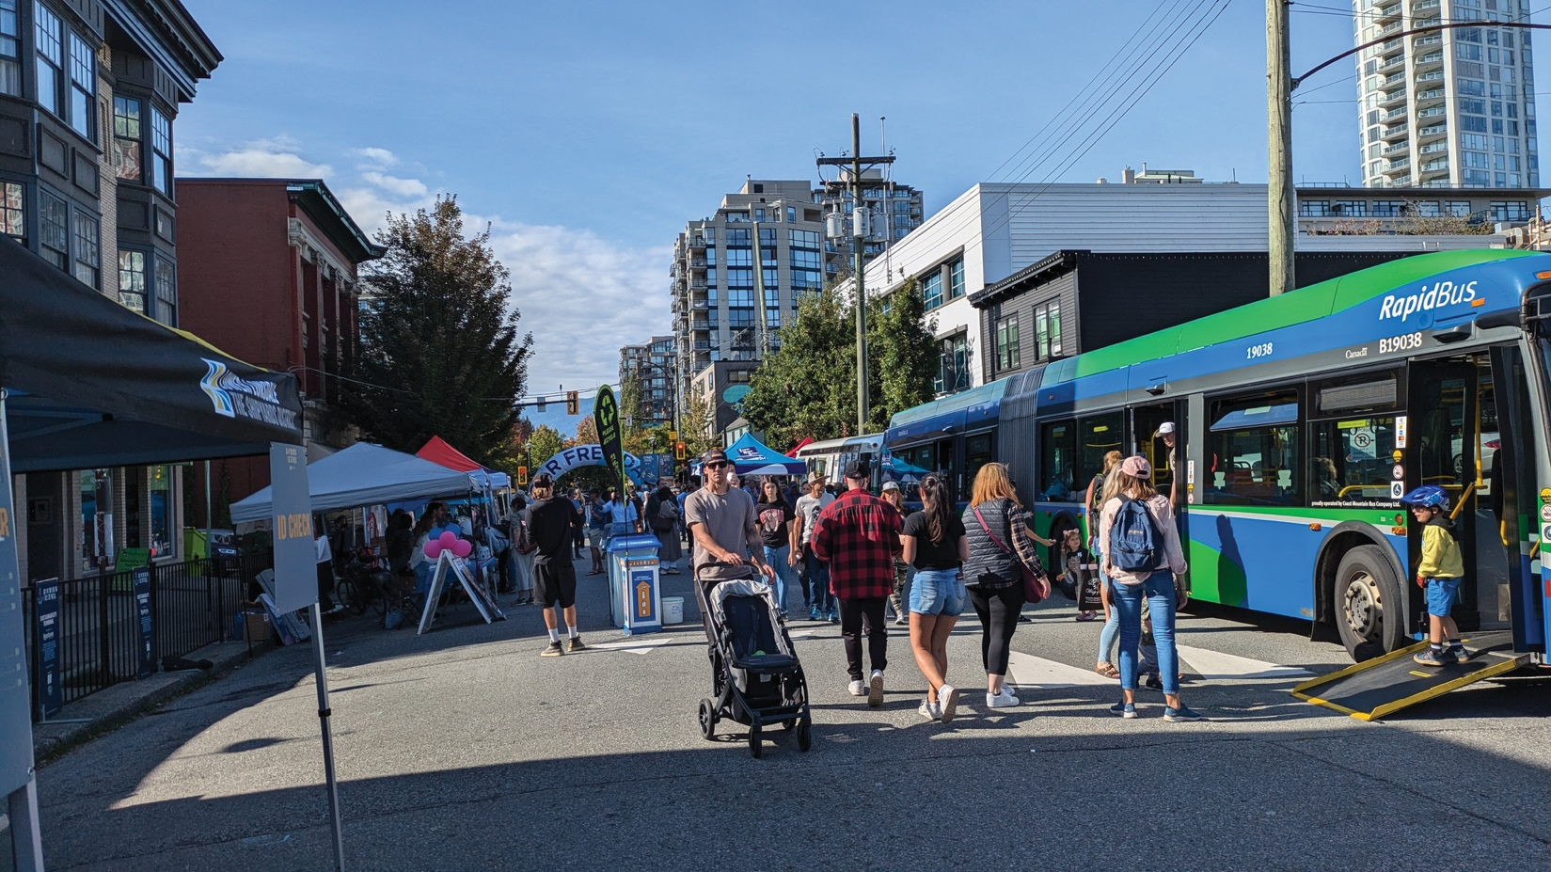

#### Procurement

Each time the City purchases goods or services represents an opportunity to support improved accessibility. Policy and practice barriers in procurement result when accessibility considerations are not explicitly requested. With an updated procurement policy that values accessibility alongside other social and environmental goals, all departments who procure goods or services can develop a regular practice of considering the needs of people with disabilities.

While procurement professionals are highly knowledgeable, accessible procurement is an emerging field, and they may not have received training about accessibility, which may result in attitudinal barriers.

When City staff lack awareness of accessibility, they may not know how to request or assess whether software or goods meet accessibility standards. This can lead to missed opportunities for improvement and the unintentional reinforcement of inaccessible practices.

Alternately, suppliers who can offer a product with better accessibility may be discouraged from a call for proposals that doesn’t explicitly value accessibility in the evaluation criteria.

Accessibility barriers can also come up for suppliers with disabilities. If the bidding portal is not accessible, some suppliers with disabilities may be excluded because of technology barriers.

If the bid process is not designed with accessibility in mind, it may also create other barriers for suppliers with disabilities. For example, if the bidding process operates on a short turnaround time, some suppliers who provide employment to disabled community members may not have time to confirm project team availability.

In partnership with the City’s Accessibility Working Group and Accessibility Steering Group, the City has developed a detailed action plan. Along with the details listed below, we also have identified the departments who will be responsible for each action item.

## Accessibility Action Plan

### Employment

#### Goal 1 | Identify, remove, or mitigate the impact of barriers in the accommodation process

**Barrier type**: Attitudinal, Policy-Practice, Information & Communication

**Actions**

1. Update job postings to include active offer of accommodations
2. Review accommodation process and policies
3. Review practices to offer accommodations to staff and job applicants
4. Provide training to hiring managers on inclusive hiring and accommodations
5. Enhance channels for job applicants to request accommodations
6. Enhance accessibility during in-person and virtual interviews
7. Expand outreach to organizations and groups that support community members with disabilities to promote available job opportunities

**Timeline:** 2025 to 2026

#### Goal 2 | Identify, remove, or mitigate the impact of barriers during the onboarding process

**Barrier type:** Policy – Practice

Actions

1. Review and update accessibility standards during new employee onboarding process, documents, and materials
2. Communicate that accommodations are available, and the process to request them when onboarding new hires
3. Document new employees’ information about accommodation needs in case of emergencies and work with employees to confidentially develop emergency plans

**Timeline:** 2025 to 2026

#### Goal 3 | Identify, remove, or mitigate the impact of Barriers when communicating or sharing information with employees

**Barrier type:** Policy – Practice

Actions

1. Review accessibility of essential employee communications and update to remove or mitigate the impact of barriers
2. Develop and communicate a process for employees to request communications, policies or any other essential documents in accessible formats when needed

**Timeline:** 2025 to 2026

#### Goal 4 | Identify opportunities to improve the workplace emergency response program

**Barrier type:** Policy – Practice, Physical, Attitudinal, Information &  
Communication

**Actions**

1. Review workplace emergency response program from an accessibility lens

**Timeline:** 2025 to 2026

### Service Delivery

#### Goal 1 | Build staff awareness about accessibility, disability and fostering inclusive workplaces

**Barrier type:** Attitudinal

**Actions**

1. Provide staff training on accessibility and disability awareness, document accessibility, accessible and inclusive community engagement

**Timeline:** 2025 and Ongoing

#### Goal 2 | Identify opportunities to improve accessibility in emergency management in the North Shore

**Barrier type(s):** Policy – Practice, Attitudinal, Physical, Information & Communication

**Actions**

1. Work in collaboration with NSEM, DNV, DWV and Sḵwx̱ wú7mesh (Squamish) and səlilwətaɬ (Tsleil-Waututh) Nations to align on accessibility standards for emergency management in the North Shore

**Timeline:** 2025 to 2026

#### Goal 3 | Identify opportunities to enhance support for community members with disabilities during emergencies

**Barrier type(s):** Policy – Practice

Actions

1. Conduct a comprehensive review of the Fire Department’s Community Disability Self-Reporting Program to identify opportunities for improvement and promotion. This voluntary program allows residents with disabilities to register their information in a database managed by the North Vancouver Fire Department.

The database serves as a valuable resource for first responders, providing critical information when responding to emergencies at properties where individuals with disabilities reside. By ensuring responders are aware of specific needs, the program enhances the safety and effectiveness of emergency response efforts. Through these efforts, the program can be further optimized to support a safer and more inclusive community

**Timeline:** 2025 to 2026

#### Goal 4 | Improve accessibility of Council documents accessed by members of the public and staff

**Barrier type(s):** Policy – Practice, Information, Communication & Technology

**Actions**

1. Review forms, checklists and commonly used public documents from an accessibility lens to identify barriers and actions to remove or mitigate their impact
2. Incorporate accessibility principles to existing guidelines to create documents, update forms and lead community engagement events
3. Create process to allow transcription of voicemails for public submissions in response to a notice
4. Improve access and raise awareness about the [Listen EVERYWHERE](https://www.listentech.com/listen-everywhere/) app that allows the public to connect Council meeting audio to personal smartphone devices, personal headphones, and/or hearing aids via Bluetooth

**Timeline:** 2025 to 2026

#### Goal 5 | Identify opportunities to enhance support for community members with disabilities through supportive funding strategies

**Barrier type(s):** Policy – Practice

**Actions**

1. Integrate accessibility as a key consideration in the City Supportive Funding Program framework

**Timeline:** 2025 to 2026

### The Built Environment

#### Goal 1 | Remove or mitigate impact of accessibility barriers in properties owned and managed by the CNV

**Barrier type:** Physical

**Actions**

1. Assess physical accessibility of City owned and managed buildings by a certified accessibility professional.
   * Assess accessibility of CNV City Hall and Gerry Brewer Building (RCMP and Police Support Services) in 2025
   * Create an implementation plan to address barriers in the short, medium, and long term

**Timeline:** 2025 to 2026 to 2027

#### Goal 2 | Ensure consistent accessible design by providing direction to all parties designing and constructing streetscape elements in the City’s rights-of-ways

**Barrier type:** Policy – Practice

**Actions**

1. Develop and implement street design guidelines, describing design objectives for sidewalks, furniture, trees, and landscaping along all public streets

**Timeline:** 2026

#### Goal 3 | Integrate accessibility principles in the design of City-wide wayfinding elements

**Barrier type(s):** Physical, Policy – Practice, Information & Communication

**Actions**

1. Integrate accessibility principles into the design of wayfinding infrastructure throughout the City, including development of:
   * + Clear standards for the design, location, and construction of wayfinding elements. This will ensure information is accessible, intuitive, inclusive, and easily understood by all
     + New design templates for signage, icons, ground markings
     + A comprehensive city-wide graphic map, and other wayfinding features that meet the need of a diverse range of users

**Timeline:** 2025

#### Goal 4 | Deliver a complete, universally accessible and high-quality pedestrian network

**Barrier type(s):** Physical, Policy – Practice, Information & Communication

**Actions**

1. Provide a complete sidewalk network on both sides of the street of all streets within a reasonable walking distance (typically 400 metres) of all key pedestrian areas and destinations like schools, community centres and frequent transit corridors. Prioritize improving the quality and comfort of existing narrow sidewalks along and within a reasonable walking distance of the City’s Main Streets
2. Deliver and encourage more pedestrian connections mid-block pathways across the City, with particular focus on north-south connections in the Lonsdale Regional City Centre, and improve connections over ravines, creeks, and through parks, where environmentally appropriate
3. Prioritize universal design and accessibility standards when designing or redesigning all streets, sidewalks, connections, and pathways using guidance from BC’s Active Transportation Design Guide

**Timeline:** 2025 to Multiyear[1]

#### Goal 5 | Develop experience-focused operational service standards for the maintenance of City assets and spaces

**Barrier type(s):** Policy & Practice

**Actions**

1. Align our asset management efforts to focus on the user experience, rather than solely focusing on asset condition.
2. Provide an improved level of service for people walking and rolling during all seasons, including more leaf and debris clearing in the fall and more snow clearing of mobility lanes and critical pathways in the winter

**Timeline:** 2025 to Multiyear[2]

### Information and Communications

#### Goal 1 | Incorporate accessibility principles into the City’s Engagement Framework

**Barrier type:** Policy – Practice, Information & Communication

**Actions**

1. Include accessibility as a guiding principle in the City of North Vancouver Engagement Framework

**Timeline:** 2025

#### Goal 2 | Set concrete, actionable steps to integrate accessibility into the City’s Engagement Framework

**Barrier type(s):** Policy – Practice, Information & Communications

**Actions**

1. Identify actions to improve accessibility in the City of North Vancouver Engagement Framework Implementation Plan

**Timeline:** 2026 to Onward

#### Goal 3 | Establish regular monitoring and internal reporting on barriers via communications channels

**Barrier type:** Policy – Practice

**Actions**

1. Log all public feedback about accessibility barriers in and when interacting with the City, and establish quarterly reviews with the City Accessibility Working Group to identify short, mid, and long term actions

**Timeline:** 2025 and Onward

#### Goal 4 | Enhance existing feedback channels

**Barrier type(s):** Technology, Information & Communication

**Actions**

1. Develop and implement feedback channels that are accessible to a wide range of users  
   Investigate opportunities to use existing tools
2. Develop an engagement plan to outreach to communities that are not commonly present in consultation, including understanding and removing or mitigating barriers to participation

**Timeline:** 2025

#### Goal 5 | Improve accessibility of CNV.org

**Barrier type(s):** Technology, Information & Communication

**Actions**

1. Assess accessibility of the City’s website to identify barriers

Develop a plan to implement website improvements in the short and midterm that prioritizes critical and serious issues

**Timeline:** 2025 to 2026

#### Goal 6 | Improve public information about accessibility of facilities and events venues

**Barrier type:** Information & Communication

Actions

1. Identify opportunities to improve public information about accessible features and services available in City-owned and managed buildings and event venues, including information when they are out of service

**Timeline:** 2025 to 2026 to 2027

#### Goal 7 | Integrate accessibility principles in the review of the City Visual Identity Standards

**Barrier type(s):** Physical, Policy – Practice, Information & Communication

**Actions**

1. Review the City’s visual identity standards to incorporate additional accessibility considerations. This includes the use of inclusive language, a portfolio of visual elements (such as logo lockups, graphic elements, colors, sizes, typography, etc.), and a set of templates for various documents and materials (e.g., posters, displays, newsletters, reports, presentations, etc.)  
     
   These guidelines will ensure that all materials are accessible and inclusive for a wide range of users

**Timeline:** 2025

### Transportation

#### Goal 1 | Deliver an all ages and abilities Mobility Lane Network that connects all our neighbourhoods and key destinations

**Barrier type:** Physical, Information & Communication

**Actions**

1. Complete the priority corridors for All Ages and Abilities (AAA) Mobility Lanes and provide improved North-South connections to key activity centres in the City. Identify new phases for network expansion on a regular basis as corridors are delivered
2. Ensure all new mobility lane infrastructure is designed to meet AAA standards
3. Upgrade existing mobility lane infrastructure to meet AAA standards, prioritizing investments on corridors with high use and the greatest potential for risk reduction
4. Make better use of low-cost, quick-build solutions, such as using temporary delineator posts to separate mobility lanes from vehicle traffic, and observing these temporary solutions in advance of upgrading to fully developed infrastructure

**Timeline:** 2025 to Multiyear

#### Goal 2 | Make our walking and rolling networks easier to use and navigate for people of all ages and abilities

**Barrier type:** Physical, Information & Communication

**Actions**

1. Deploy a user-friendly mobility wayfinding system at key locations across the City, and provide this in an open format to encourage third-party development of wayfinding solutions. Coordinate with North Shore governments to ensure sub-regional alignment
2. Require the provision of direct, unobstructed, and protected routes for people walking or rolling, as part of the permitting process for construction and development, special events, and public works

**Timeline:** 2025 to 2026 to 2027 to 2028

#### Goal 3 | Provide abundant amenities that increase the enjoyment of walking and rolling

**Barrier type:** Physical

**Actions**

1. Expand amenities such as benches, secure bicycle parking, weather protection, and washroom facilities, and create an inventory and prioritization schedule with community input

**Timeline:** 2025 to 2026 to 2027 to 2028

1. Ensure public micromobility parking spaces are designed to accommodate e-bikes and cargo bikes, especially along Main Streets and Shared Streets

**Timeline:** 2025 to Multi-year

#### Goal 4 | Improve access to shared micromobility services for everyone

**Barrier type:** Physical, Policy & Practice

**Actions**

1. Work with shared micromobility service providers to ensure there is equitable fleet distribution, and prioritization across the City’s AAA Mobility Lane Network, and close to major destinations
2. Work with shared micromobility service providers to ensure devices do not impede other travellers through application of end-of-trip procedures and education programs
3. Advocate for new incentives and loan programs from senior levels of government to support greater uptake of electric micromobility devices, including e-bikes and other emerging devices

**Timeline:** 2025 to 2026 to 2027 to 2028

#### Goal 5 | Create enabling conditions for enhanced transit service and coverage across the City

**Barrier type:** Physical, Policy & Practice

**Actions**

1. Work with TransLink to expand and enhance local transit service, ensuring all businesses and residents are within a reasonable walking distance of the Major Transit Network. This involves protecting and designing space for fast and reliable transit

**Timeline:** 2025 to 2026

1. Work with TransLink to plan, design, and implement measures, such as signal priority and bus-only lanes, prioritizing investments at unreliable locations on the Frequent Transit Network

**Timeline:** Ongoing to Multi-year

#### Goal 6 | Support an inclusive transit system that is easy to understand, and accommodates people of allabilities

**Barrier type:** Physical, Policy & Practice

**Actions**

1. Ensure all transit passenger facilities are designed to be universally accessible
2. Provide consistent digital and physical wayfinding and signage
3. Provide high-quality stops by working closely with partners to expand the availability of passenger waiting shelters, real-time information, benches, ample bike parking, improved lighting, and washrooms in high ridership and transfer areas

**Timeline:** Ongoing to Multi-year

#### Goal 7 | Create enabling conditions for mobility hubs to provide seamless connections between transit and other modes

**Barrier type:** Policy & Practice

**Actions**

1. Support the establishment of mobility hubs in Lower Lonsdale, Central Lonsdale, and other sites with frequent or rapid transit. These hubs will include improved transit priority measures, increased availability of car-sharing and ride-hailing options, and plentiful walking and rolling infrastructure

**Timeline:** Ongoing to Multi-year

#### Goal 8 | Support easier access to car-sharing and carpooling services

**Barrier type:** Policy & Practice

**Actions**

1. Enhance accessibility requirements for car-sharing fleets and work with service providers to increase fleet distribution to ensure effective spatial coverage across all neighbourhoods
2. Work with service providers to increase car-share access for families, lower income households, and people with mobility limitations

**Timeline:** Ongoing to Multi-year

#### Goal 9 | Minimize the potential for conflict where different street users come together

**Barrier type:** Physical, Information & Communication

**Actions**

1. Increase the separation of different users at our busiest intersections, particularly for the protection of vulnerable road users
2. Expand the use of measures like pedestrian- and cyclist-activated signals, dedicated and protected turning signal phases, centreline medians, “no right turn on red” restrictions, and advanced pedestrian and cyclist crossing phases at intersections that have high volumes of people using different transportation modes

**Timeline:** Ongoing to Multi-year

#### Goal 10 | Manage travel speeds and access to improve neighbourhood safety and livability

**Barrier type:** Policy & Practice

**Actions**

1. Create a network of 30 km/h streets that includes Local Streets and streets around schools, parks, and community centres. Expand the network of Shared Streets, where vehicle traffic is limited to speeds of pedestrians.
2. Decrease speed limits on other street types to improve safety and comfort for all travellers

**Timeline:** Multi-year[3]

#### Goal 11 | Support enforcement that reduces dangerous conduct and prioritizes protection for vulnerable road users

**Barrier type:** Policy & Practice

**Actions**

1. Update City bylaws to ensure the safety needs of our most vulnerable road users are prioritized
2. Work with the Province and North Vancouver RCMP to implement electronic enforcement to deter speeding, red light running and other dangerous behaviour at high-risk intersections and streets

**Timeline:** Ongoing to Multi-year

#### Goal 12 | Make it easier for everyone to be seen while travelling

**Barrier type:** Physical

**Actions**

1. Improve street and pathway light levels with prioritization at poorly lit intersections.
2. Increase visibility of travel lanes, medians, crosswalks, and signage under all conditions by applying and maintaining retroreflective signage, tape and paint

**Timeline:** Ongoing to Multi-year

#### Goal 13 | Review curb space use across the City to better meet the needs of street users

**Barrier type:** Policy & Practice

**Actions**

1. Undertake a review of the City’s Resident Exempt Parking Program, and work with residents and businesses to develop a more comprehensive approach to vehicle permitting that meets the needs of street users, manages spillover concerns associated with off-street reductions, and better reflects the high value of street space

**Timeline:** Completed in 2025[4]

#### Goal 14 | Ensure there are sufficient loading zones, pick-up and drop-off zones, and accessible parking spots in high-demand locations

**Barrier type:** Physical

**Actions**

1. Provide more accessible on-street parking spaces in close proximity to shops, services, and key destinations across the City

**Timeline:** Ongoing to Multi-year

#### Goal 15 | Work with TransLink and other partners to create a mobility management system to optimize signals, curbside regulations, and real-time traveller information

**Barrier type:** Policy & Practice

**Actions**

1. Provide real-time curb and street data as part of the City’s digital wayfinding program. This can encourage third-party providers to use of this data, expanding the reach of City capabilities

**Timeline:** Multi-year

### Procurement

#### Goal 1 | Integrate accessibility into the City’s purchasing requirements

**Barrier type:** Policy & Practice

**Actions**

1. Update current Sustainability policy to integrate accessibility considerations in the competitive bidding process
2. Add request to tender document to provide information about vendor accessibility practices in alignment with BC Accessibility legislation
3. Integrate accessibility criteria into the vendor evaluation process
4. Add accessibility requirements for new training purchases

**Timeline:** 2025 to 2026

#### Goal 2 | Learn best practices and approaches to accessibility in procurement from similar public sector organizations

**Barrier type:** Policy & Practice

**Actions**

1. Research and discuss best practices with Municipal Procurement community of practice

**Timeline:** Ongoing

## Monitoring and Evaluation

The CNV Accessibility Working Group meets quarterly to review progress and discuss new barriers recorded in the Barrier Tracking Log document received from the following sources:

1. Feedback channels available to the public that are posted on the City’s website
2. The North Shore Accessibility Advisory Committee
3. Disability serving organizations that supported the development of the plan. (We will continue searching for and reaching out to other organizations that have a deeper understanding of barriers experienced by their client groups)
4. The CNV Accessibility Employee Resource Group
5. City led public consultation conducted through the year

1. The Ongoing – Multi-year timeline includes actions that are part of the long-term work outlined in the Mobility Strategy, which will take years to complete. For example, sidewalk improvements are ongoing and happen each year.
2. The Ongoing – Multi-year timeline includes actions that are part of the long-term work outlined in the Mobility Strategy, which will take years to complete. For example, sidewalk improvements are ongoing and happen each year.
3. The multi-year timeline includes actions that are part of the long-term work outlined in the Mobility Strategy, which will take over 4 years to complete.
4. The City of North Vancouver’s Mayor and Council approved the Curb Access and Parking Plan in April 2025